ORDER FULFILMENT

Date: 05-07-2023

Overview:

Process orchestration for orderfulfillment involves the coordination and management of various tasks, systems, and stakeholders to streamline the orderfulfillment process. It ensures that orders are processed efficiently, inventory is managed effectively, and customers receive their products in a timely manner.

Objective:

The objective of implementing process orchestration for orderfulfillment is to optimize and automate the orderfulfillment process, improve operational efficiency, reduce errors, and enhance customer satisfaction.

Client/Company Name: Surge IT Technology Solutions LLP.

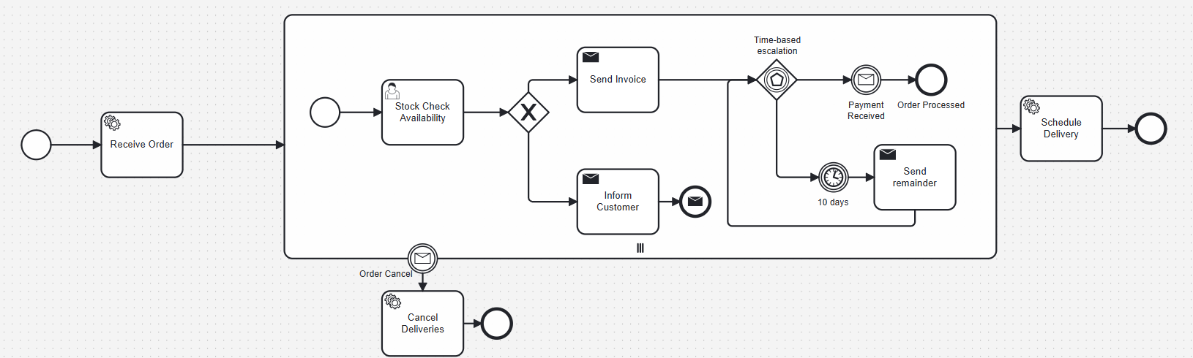

Order fulfilment Workflow BPMN Diagram

Industry: E-commerce

Describe the Problems the client is facing in detail:

* Manual and disjointed order processing leading to errors and delays.
* Lack of real-time visibility into inventory levels and order status
* Inefficient use of resources due to redundant tasks and processes
* Difficulty in scaling operations to meet fluctuating demand.
* Inconsistent customer experiences due to process inefficiencies

Describe the tools the client is using currently:

* Legacy order management systems
* Manual data entry and spreadsheet-based tracking
* Disparate systems for inventory management, order processing, and shipping
* Limited automation capabilities, relying heavily on manual intervention.

Describe the tools/automation suggested by surge team:

* Implementation of a comprehensive process orchestration platform
* Integration with existing systems such as ERP, CRM, and WMS
* Automation of order processing, inventory management, and shipment tracking
* Real-time monitoring and reporting capabilities.
* Scalable architecture to accommodate growing business needs.

Describe the Solutions provided in detail:

* Integration with existing systems to streamline data flow and eliminate manual data entry.
* Automation of order processing, including order validation, picking, packing, and shipping
* Implementation of real-time inventory management system to track inventory levels and ensure accurate order fulfilment.
* Deployment of monitoring and reporting tools to provide visibility into the order fulfilment process.
* Scalable architecture designed to handle peak demand periods and future growth.

Implementation Process:

* Assessment of current order fulfilment process and identification of pain points
* Selection and customization of process orchestration platform
* Integration with existing systems and data migration
* Development and testing of automated workflows.
* Training for staff on new processes and systems
* Rollout of process orchestration solution and monitoring of performance

Results:

* Reduction in order processing times.
* Decrease in order errors and discrepancies.
* Improved inventory accuracy and visibility
* Increase in customer satisfaction scores.
* Cost savings due to reduced manual labour and improved efficiency.

Key Metrics:

* Order processing time.
* Order accuracy rate.
* Inventory turnover rate.
* Customer satisfaction scores
* Cost savings from automation

Lessons Learned:

* Importance of thorough planning and stakeholder involvement during implementation
* Need for ongoing monitoring and optimization of processes.
* Value of scalability and flexibility in adapting to changing business needs

Conclusion:

* Process orchestration for order fulfilment has significantly improved our operational efficiency, accuracy, and customer satisfaction.
* By automating and streamlining our order fulfilment processes, we have been able to meet customer demands more effectively and achieve cost savings through improved efficiency.

Additional Information:

* Case studies or testimonials from clients who have successfully implemented process orchestration for order fulfilment.
* Resources for further reading on process orchestration best practices and implementation strategies
* Contact information for inquiries or consultations regarding process orchestration solutions.